FREESIC - 2014
Luxembourg

FREESIC Final Field Test, 5th June 2014

INFORMATION PACK
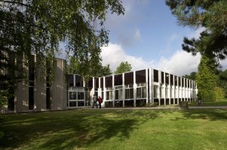
Project Final Review Day
- Arrivals 9:00am till 9:20am
- Commencing 9:30am
- Lunch will be provided
Venue:
University of Luxembourg
Campus Kirchberg
Faculty of Science, Technology and Communication, Salle Paul Feidert
6, rue Coudenhove-Kalergi
L-1359 Luxembourg-Kirchberg
T.++352 46 66 44 5000
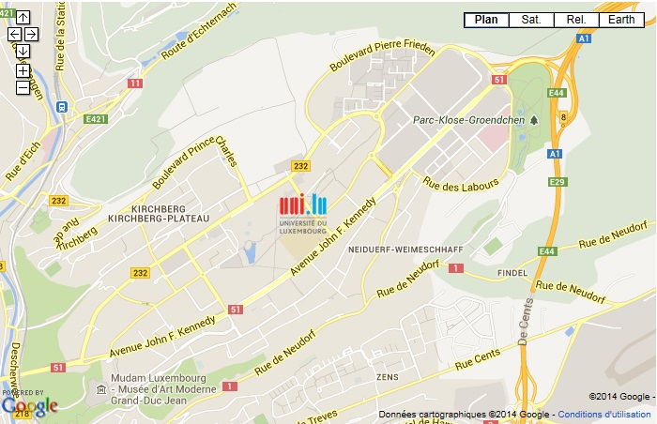
http://wwwen.uni.lu/fstc/contact_and_access

Travel to Luxembourg:
BY PLANE
Findel Airport
Frankfurt‐Hahn + Bus
Brussels‐Charleroi + Bus
Koeln‐Bonn + Train
BY TRAIN
From Paris ‐ TGV
How to reach the Campus Kirchberg, Salle Paul Feidert
FROM FINDEL AIRPORT
Findel Airport - From there, ? 10 minutes by taxi. Public transport: city bus n° 16 to bus stop " Coudenhove-Kalergi ". You then have to walk for about 2 minutes to the Campus de Kirchberg, salle Paul Feidert
FROM CENTRAL RAILWAY STATION
About 15 minutes by taxi or city bus n° 18 (direction "Kirchberg") to bus stop "University – Campus Kirchberg,
BY CAR
The - Campus de Kirchberg, salle Paul Feidert is located in the north of Luxembourg city. On the motorway A1 Luxembourg‐Trier (Treves), take exit "Kirchberg".
Useful links:
Luxembourg City Tourist Office
A Hotel Directory
LUXAIR: the airline of Luxembourg
CFL: Luxembourg Railways
Bus routes and schedules
Accomodation:

NOVOTEL Luxembourg Kirchberg
6 rue Fort Niedergrünewald  Quartier Européen Nord  Plateau de Kirchberg  L-2226 LUXEMBOURG | -> Hotel Overview

Parc Plaza Hotel Luxembourg
5 Avenue Marie-Thérèse  2132 Luxembourg | -> Hotel Overview

SOFITEL Luxembourg Europe
4, Rue du Fort Niedergrünewald  Quartier Européen Nord  Plateau de Kirchberg  L-2015 Luxembourg | -> Hotel Overview

City Hotel Luxembourg
Coin Av. de la Liberté / 1 Rue de Strasbourg  BP 2126  L - 1021 Luxembourg | -> Hotel Overview

Hotel Best Western Plus Victor Hugo
Grand Hôtel Victor Hugo  3 – 5 Avenue Victor Hugo – L1750 Luxembourg | -> Hotel Overview

Golden Tulip Central Molitor
28 Avenue de la Liberté, L-1930 Luxembourg | -> Hotel Overview

IBIS Luxembourg Aéroport
Route de Trèves  L-2632 Findel | -> Hotel Overview

